Use of Bio-Zyme Bacteria from TRM Biologics, Inc.
in a 50 Acre STA (Stormwater Treatment Area)
Test Plot in the Florida Everglades

Introduction
South Florida receives heavy rainfall which is the area’s primary source of fresh water. Stormwater runoff carries nutrients including Nitrogen, Phosphorous and both organic and inorganic residuals into the receiving and treatment areas.

These Stormwater Treatment Areas (STAs) are wetlands that remove and sequester nutrients through plant growth and accumulation of dead plant material in the STA zones. In the Florida Everglades, there are more than two dozen pump stations, 350 water control structures and more than 600 miles of levees and canals. Repairs, maintenance, erosion control and debris cleanup are essential and ongoing tasks. The Everglades Stormwater Treatment Areas collectively comprise 57,000 acres of effective treatment area.

The location of the six STAs is shown in the drawing below: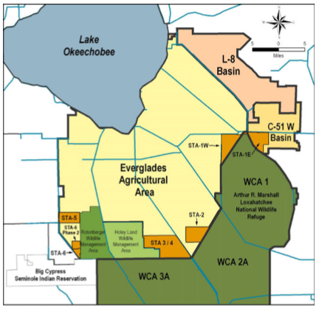
Range of Challenges

The 6 STA zones treat an immense amount of water with a total processed flow of
1.4 million acre-feet of water. They retained a total of 208 tons of total Phosphorous (86% removal).

There is a continuous program of planting, seeding, herbicide treatment and removal of excess plant material that is a huge and costly effort. This program is driven by the nutrient trapping performed by the STA zones along with the plant life and sludge build up that occurs as a result.

The first zone of the STA system in operation was STA-1W which began operation in 1994. This STA comprises 6,544 acres of treatment.

While plant growth is a key part of the design of any wetland, STA-1W has suffered from excessive organic muck and excess dead and floating plant material. The excess build up prohibits growth of healthy plants. This interferes with nutrient removal as nutrient removal is at its best when the zone is actively growing new, healthy plants.

STA-1W Test Site

As this STA was the first in service, it has a buildup of organic sludge and dead plant material that reduces nutrient uptake. The primary focus of vegetation management in STA-1W during WY2016 was the rehabilitation of Cell 1A in the Eastern Flow-way. Eight-hundred ac of primrose willow, water pennywort (Hydrocotyle umbellata) and floating cattail tussocks had been treated or mechanically removed in this cell during WY2015. A schematic is shown below:

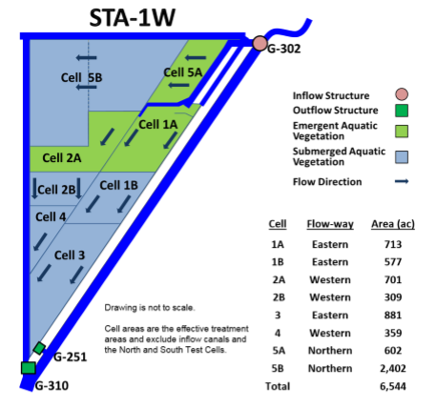

With the excess accumulation of organic muck, dead plants and less than ideal new plant (emergent) growth for nutrient uptake, the SFWMD agreed to a trial of Bio-Zyme bacterial products in a 50 acre secluded zone.

The SFWMD decided to concentrate on evaluating the use of Bio-Zyme in Cell 1A. This is the oldest cell in operation existing for over 10 years. Cell 1A would be considered as a bell-weather for how the others will age. This cell is not aging well. It is 2-3 foot deep but has formed some floating false bottom of unconsolidated material that floats after draw-downs designed to consolidate this material.

Discussion between SFWMD and Bio-Zyme / TRM Products personnel centered on the best possible dosing mechanisms. The collective decision was to introduce Bio-Zyme in “open” water across Cell 1A of STA-1W and not on the surface of the floating material. Due to the shallow depth and high wind/wave action in the 800 acre cell all agreed that Disolved Oxygen shouldn’t be much of a concern.

The goal of the trial was for Bio-Zyme use to eliminate or at least help consolidate organic matter in the sediment so that the layers adhere to one another and a false bottom does not form or float after routine draw-downs. Another fundamental goal was Phosphorous reduction from the water column (incorporation of P into an unavailable form), but for the trial period sludge and muck reduction was the main objective.

Bio-Zyme Bio-Generator and Dose Procedures

A standard Bio-generator was used to prepare the Bio-Zyme products for dosing as follows:
- 500 gallon polyethylene tank
- Equipped with vigorous diffused aeration
- Filled on a Friday with water, 5 lbs of Nitrifier Activator, 2.5 gallons of concentrated Nitrifiers, aerate continuously until Wednesday
- Wednesday, continue aerating, add 12.5 lbs Bio-Zyme bulk powder, aerate until Friday.
- Friday, dose entire tank to the treatment area, refill 500 gallon tank as noted above.

The 500 gallons of brewed product were sprayed onto the surface of a 25 acre section of the 50 acre evaluation zone. As the STA receives considerable wind and rainfall the expectation was that by applying the Bio-Zyme in a 25 acre section of the 50 acre evaluation zone the product would naturally migrate and influence the entire 50 acres. A boat was used to apply the 500 weekly gallons of Bio-Zyme in a zig-zag pattern.

Dosing began in July of 2016 and continued for 6 months through December, 2016.

Results of Bio-Zyme Dosing

The following results were compiled by personnel from Aquatic Vegetation
Control and sent to the project manager:

To: Eric Crawford, STA Operations, Management and Coordination ,SFWMD

Results (Compiled by Elroy Timmer, Biologist, Aquatic Vegetation Control):

- All the dozens of tussocks and mud islands that existed before treatment are gone even though the water on the staff gauge is down from 11 feet before treatment to 10 feet 3 months after treatment. With the water drop of 12 inches the tussocks should be more visible but instead are gone.
- It is hard to even identify the area because of the dramatic change in appearance that has occurred.
- A little vegetation remains in one or two spots but the vegetation is lying flat on the water, yellow and unhealthy because the mud support for them no longer exists.
- The water is clear about 8 inches below the surface. Before the water level dropped there was about 1.5 feet of water above the mud. About 15 inches of soil still exists below the clear water. In two years we would expect those 15 inches to be reduced to a few inches.
- The area outside of the plot to the east is still unchanged with mud up to the surface. The water evidently flows west because the area outside the plot to the west has responded well to the treatments with all the tussocks and mud islands are gone in that area.
- The airboat glides easier in the plot area because the organic soil is 6-8 inches below the water surface.

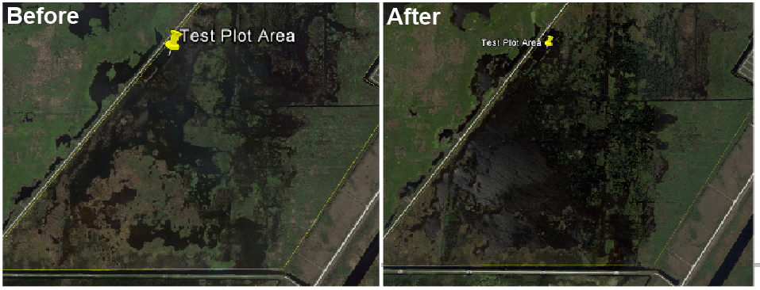
The amount of removal of dead vegetation and organic muck is best seen in the Google Earth photos below, with ‘Before’ on the left and ‘After’ Bio-Zyme on the right:

The clear water zones on the right hand side photo show the powerful change caused by Bio-Zyme dosing.

